[CEN 323 ] Computer Organization & Assembly Language
Lab 12 Journal

Name : Fatima Asad
Enrollment Number: 01-135232-020

Lab Deliverables (submission guideline)

Create a folder named after your enrollment number and add the following files:
  - Create a folder named YourRollNumber_Lab12 containing:
- .asm files of the 2 practice tasks.
- Add full screen screenshots of the code and output in this word file.
  - Zip the Folder and upload to LMS.

Lab Task

Task 1:
Code (TEXT):
org 100h
jmp main

arr1 dw 10,20,30,40,50
arr2 dw 99,88,77,66

buf1 dw 5 dup(0)
buf2 dw 4 dup(0)

notice db "arrays are copied. $"

transfer:
push bp
mov bp, sp

push si
push di
push cx

mov si, [bp+8]
mov di, [bp+6]
mov cx, [bp+4]

move_data:
mov ax, [si]
mov [di], ax

add si, 2
add di, 2

dec cx
jnz move_data

pop cx
pop di
pop si

pop bp
ret 6

main:
mov ax, arr1
push ax

mov ax, buf1
push ax

mov ax, 5
push ax

call transfer

mov ax, arr2
push ax

mov ax, buf2
push ax

mov ax, 4
push ax

call transfer

mov ah, 09h
mov dx, offset notice
int 21h

mov ax, 4C00h
int 21h

Screenshot (CODE):
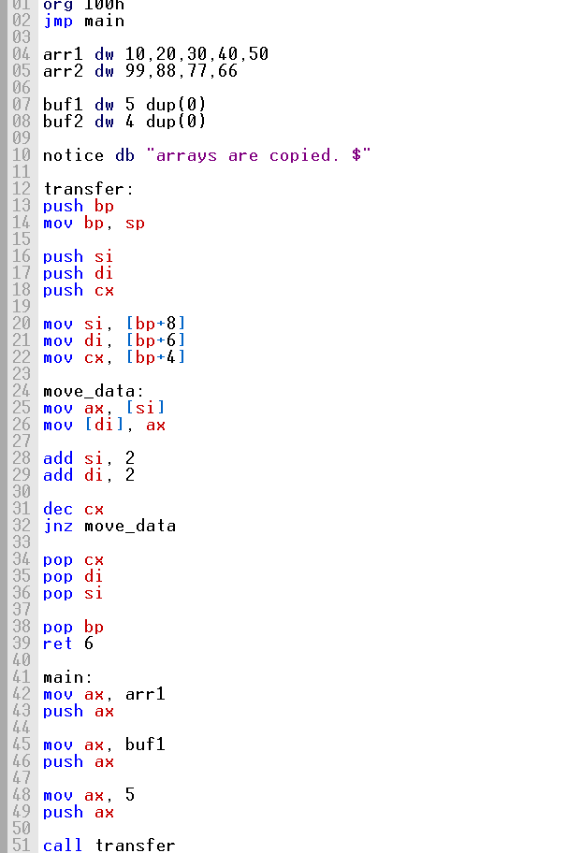

Screenshot (OUTPUT):
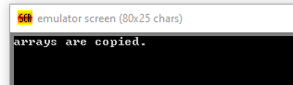

Task 2:
Code (TEXT):
org 100h

jmp main

nums1 dw 5,2,5,7,5
nums2 dw 8,9,8,1,8

label1 db "Replacements in array 1: $"
label2 db 13,10,"Replacements in array 2: $"

scanReplace:

push bp
mov bp, sp

sub sp, 2

push si
push cx

mov word [bp-2], 0

mov si, [bp+8]
mov cx, [bp+6]
mov dx, [bp+4]

scan_loop:

mov ax, [si]

cmp ax, dx
jne no_match

mov word [si], 0

inc word [bp-2]

no_match:

add si, 2

dec cx
jnz scan_loop

mov ax, [bp-2]

pop cx
pop si

mov sp, bp
pop bp

ret 6

showDigit:

add al, 30h

mov dl, al
mov ah, 02h
int 21h

ret

main:

mov ax, nums1
push ax

mov ax, 5
push ax

mov ax, 5
push ax

call scanReplace

mov ah, 09h
mov dx, offset label1
int 21h

call showDigit

mov ax, nums2
push ax

mov ax, 5
push ax

mov ax, 8
push ax

call scanReplace

mov ah, 09h
mov dx, offset label2
int 21h

call showDigit

mov ax, 4C00h
int 21h

Screenshot (CODE):
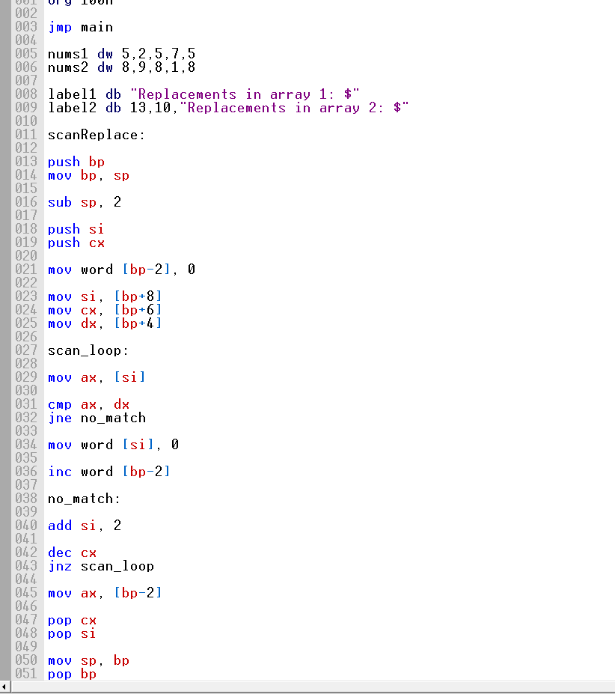

Screenshot (OUTPUT):

